Ubuntu use GDAL in Java

1.

sudo add-apt-repository ppa:ubuntugis/ppa && sudo apt-get update

sudo apt-get install gdal-bin

sudo apt-get install libgdal-dev

sudo apt-get install libgdal-java

test gdal:

gdalinfo –version

gdal some binary tools in:

/usr/bin/gdalinfo

gdal lib/so files in:

/usr/lib/libgdal.a

/usr/lib/libgdal.so

gdal include files in:

/usr/include/gdal/gdal_priv.h

Gdal jar:

/usr/share/java/gdal.jar

gdal java interface jni file:

/usr/lib/jni/libgdaljni.so

2.

create a new console java program using intellj idea.

In project structure add gdal.jar

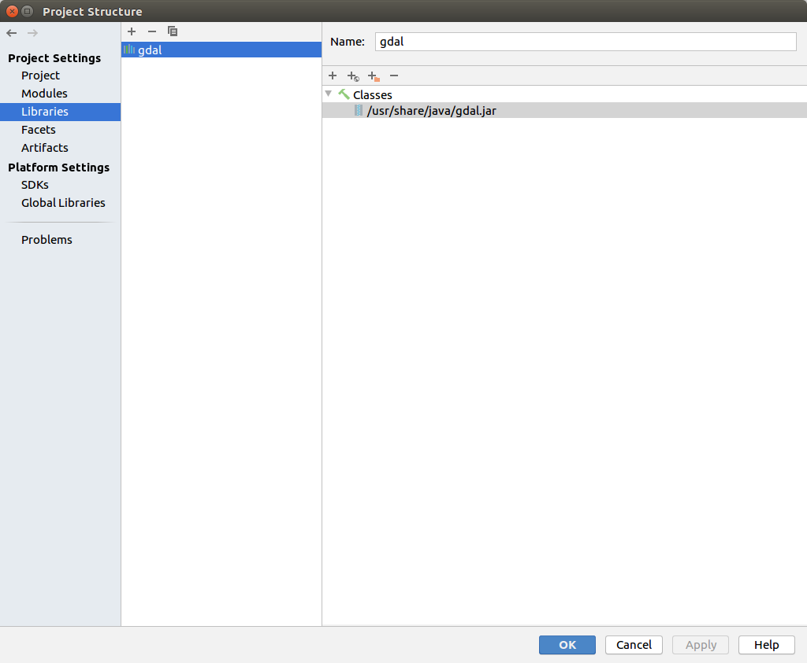

in *run->edit configuration->vm option:*

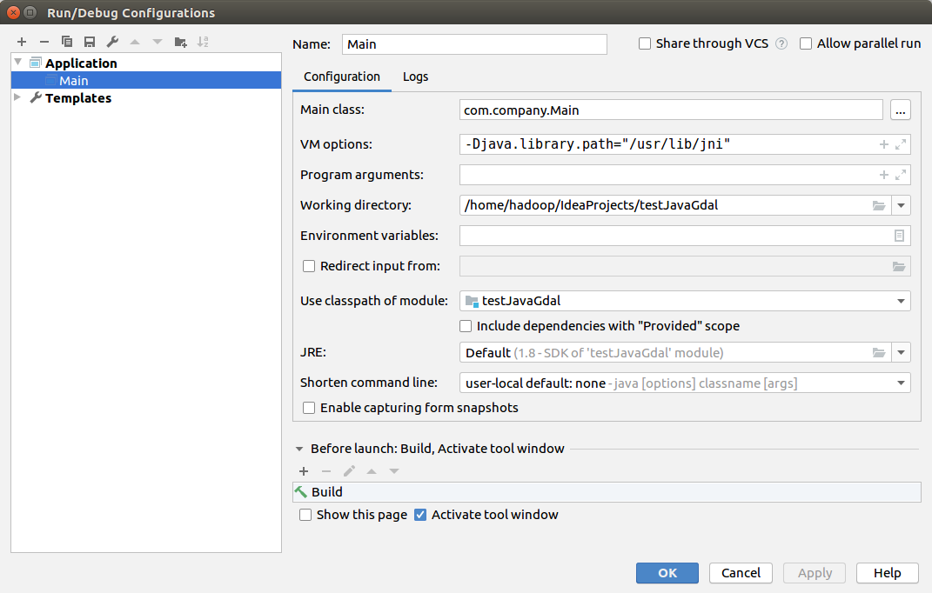

3. write codes:

**package** com.company;

**import** org.gdal.gdal.Dataset;

**import** org.gdal.gdal.gdal;

**public class** Main {

**public static void** main(String[] args) {

*// write your code here*

*//run->edit configuration->vm option: -Djava.library.path="/usr/lib/jni"*

System.***out***.println(System.*getProperty*(**"java.library.path"**));

gdal.*AllRegister*();

Dataset hDataset = gdal.*Open*(**"/home/hadoop/my_temp_data/fy4lst/FY4A_01911231160000_LST_4000M_GLL.tif"**) ;

**int** nband = hDataset.getRasterCount() ;

**int** xsize = hDataset.getRasterXSize() ;

**int** ysize = hDataset.getRasterYSize() ;

System.***out***.println(xsize + **" "** + ysize + **" "** + nband );

hDataset.delete();

}

}

build and run OK!